DIT 637 Smart and Secure Systems
TT04 Experiencing DevSecOps - A Mobile App with GitHub Actions and OWASP ZAP
06/20/2024 Developed by Clark Ngo
07/31/2025 Reviewed by Rajdeep Singh Golan
03/04/2026 Improved by Clark Ngo
School of Technology & Computing (STC) @ City University of Seattle (CityU)

Key Concepts and Tools for Cloud-based Full Stack Continuous Integration & Deployment (CI/CD)

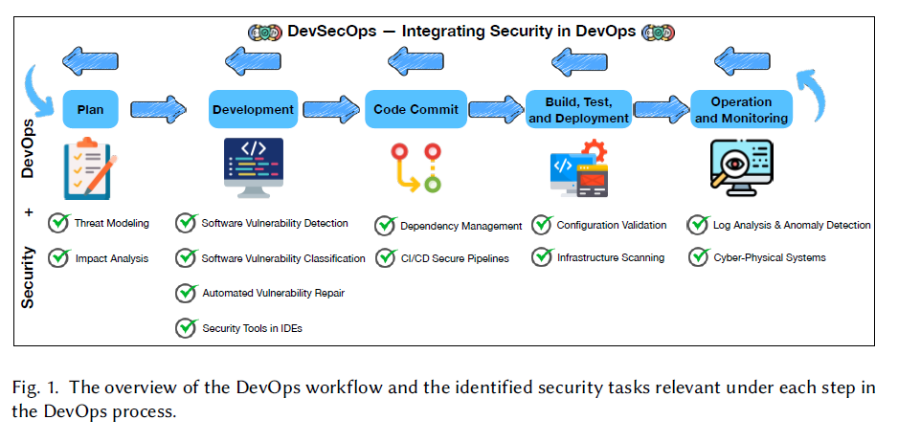

Continuous Integration (CI) and Deployment (CD)
GitHub Actions:
To automate the testing and deployment process. When code is pushed to the repository, GitHub Actions can automatically run tests and deploy the application to Amazon EC2, saving you time and effort. It can also run a security scanner like ZAP.
- https://docs.github.com/en/actions/learn-github-actions/understanding-github-actions#overview

Open Worldwide Application Security Project (OWASP) Zed Attack Proxy (ZAP):
An open-source web application security scanner maintained by OWASP. It is used to find security vulnerabilities in web applications during development and testing phases.
- https://github.com/marketplace/actions/zap-baseline-scan

YAML (“YAML Ain’t Markup Language” or “YAML ain’t markup language”):
- https://yaml.org/
- A YML file is a text document that contains data formatted using YAML
- YAML is a human-readable data serialization language commonly used for writing configuration files.
- Comparison with Other Formats:
  - XML, which stands for Extensible Markup Language, is a generalized markup language. It offers a structured yet flexible syntax and defined document schema. However, XML can be verbose and harder to read.
  - JSON (JavaScript Object Notation) is a language-independent format inspired by JavaScript. It’s concise and widely used but lacks some features like comments and multiline strings.
- YAML strikes a balance between readability and structure. It’s often used for configuration files due to its intuitive syntax and human-friendly format.
  - Basic Syntax:
  - Indentation: YAML uses indentation (spaces or tabs) to define nested structures.
  - Scalars: Represent simple values (strings, numbers, Booleans).
  - Collections: Include lists (arrays) and dictionaries (key-value pairs).
  - Comments: Start with # and provide context or explanations.
  - Explicit Data Types: Specify data types (e.g., strings, integers) explicitly.

Example: Movie Search Application
To practice and demonstrate the capabilities of React Native and Express in creating real-world applications, like searching for movies on Netflix.

Uploading one image files to your GitHub Repository generated from GitHub Classroom
- The screenshot of your ‘Scan ZAP Website – Zap Scan’ as ‘first_last_zap_scan.png’ by using your first and last name.

User Case
As a movie enthusiast using a mobile device, I want to search and browse a list of movies with details such as title, genre, and year, so that I can easily find information about movies I am interested in while on the go.
Note: the user story didn’t change. The question then is why we need MongoDB Atlas, ExpressJS, GitHub Actions, and Amazon EC2.

Why Do We Need a Backend and Database?
- Data Management:
  - Database: Storing and managing large amounts of movie data (titles, genres, years, etc.) efficiently. A database like MongoDB Atlas is ideal for handling such documents and providing quick access to them.
  - Backend: Facilitating the retrieval, manipulation, and updating of data from the database. The backend (using ExpressJS) acts as an intermediary that processes requests from the frontend, queries the database, and sends the relevant data back to the frontend.
- Business Logic:
  - Backend: Encapsulating the business logic required to process data and perform operations such as filtering movies by genre, searching for specific titles, and handling user preferences. It separates the logic from the frontend, making the application more modular and easier to maintain.

Why Do We Need Cloud Deployment?
- Scalability:
  - Cloud Deployment (e.g., Amazon EC2): Allows the application to scale up or down based on demand. As more users search and browse movies, the cloud infrastructure can handle increased traffic without performance issues.
- Availability and Reliability:
  - Cloud Deployment: Ensures that the application is highly available and reliable. Cloud providers offer features such as load balancing, automated backups, and disaster recovery, which help keep the application running smoothly.
- Global Access:
  - Cloud Deployment: Provides global access to the application. Users from different parts of the world can access the service with low latency, ensuring a seamless experience.

Why Do We Need Full-Stack Development?
- Limited Data Handling:
  - React Native alone cannot efficiently handle large datasets or complex queries. It is primarily a frontend framework meant for building user interfaces, not for managing or processing data.
- No Data Persistence:
  - Without a backend and database, data would be stored locally on the device, making it inaccessible if the user switches devices or uninstalls the app. A cloud database ensures that data is persistent and accessible from anywhere.
- Security Concerns:
  - Storing and processing data directly on the client-side exposes it to security risks. A backend server ensures data is processed securely and can implement necessary security protocols.
- Separation of Concerns:
  - Maintaining a clear separation between frontend and backend simplifies development and maintenance. It allows each part to be developed, tested, and scaled independently.

Configuring environment variables for GitHub Actions
- Create a Secret for MongoDB Atlas Connection
  - Go Settings > Secrets and Variables > Actions > Secrets > New repository secret.
    - Name: MONGODB_URI
    - Value: (add your MongoDB connection string ‘mongodb+sr....’ Just paste the raw connection string, without any quotes)
Click Add Secret

GitHub Actions with OWASP ZAP
Open the project in GitHub.
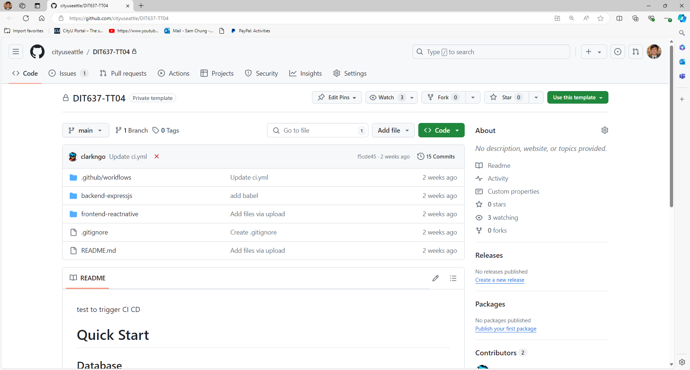

Running ZAP
- Go to Actions Tab.


- Select the most recent workflow.
If this is not available due to no initial workflow that was run skip this section and go to the step Triggering GitHub Actions.
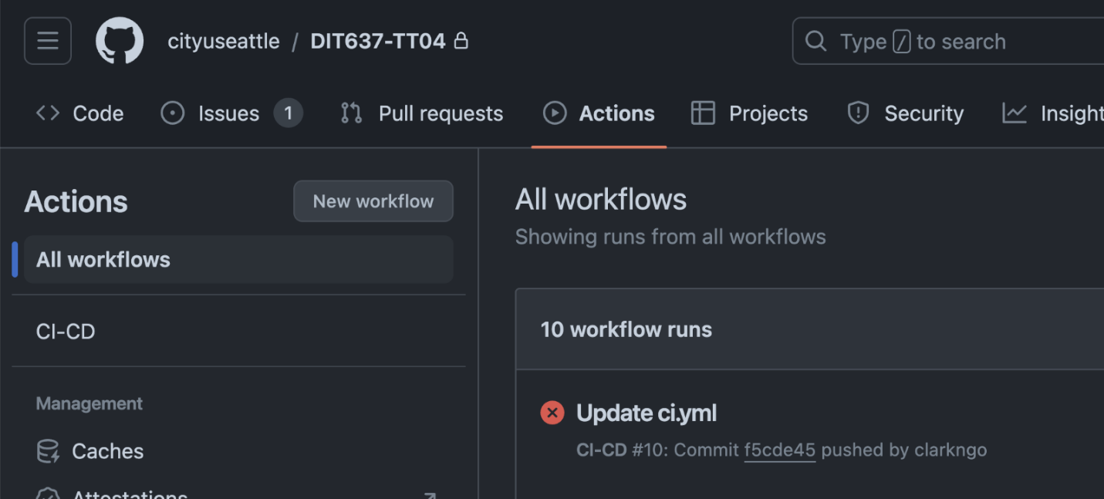

- Click Re-run all jobs.
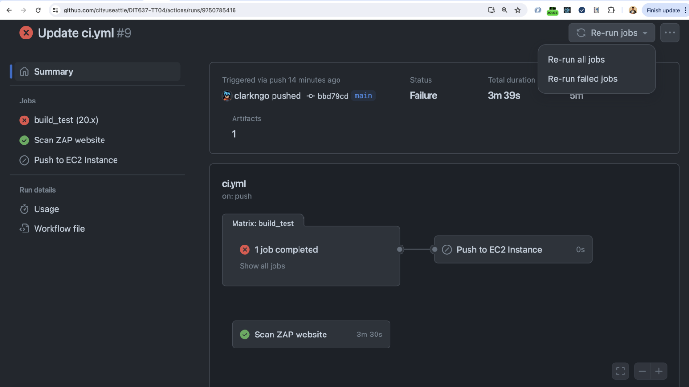

Triggering GitHub Actions
- Edit your README.md to add any word.
For example: click edit icon for README

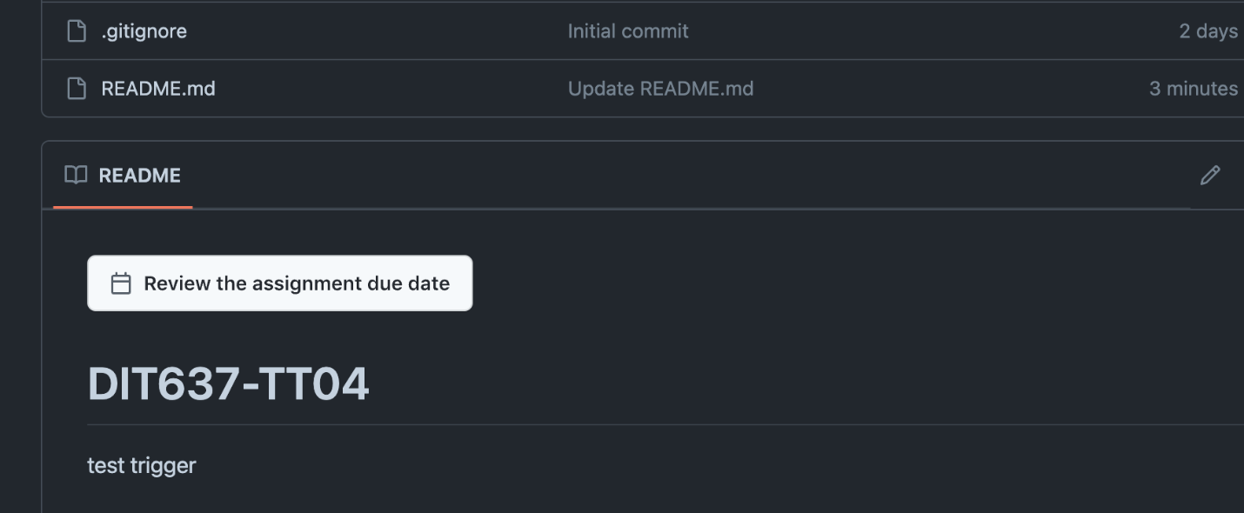
2. Add the word “test trigger” or any word and Commit Changes
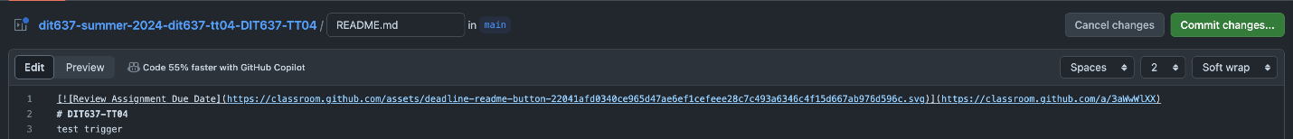
3. Check the Actions tab

- Click on the Workflow (Update README.md)
- Click Re-run jobs -> Re-run all jobs.

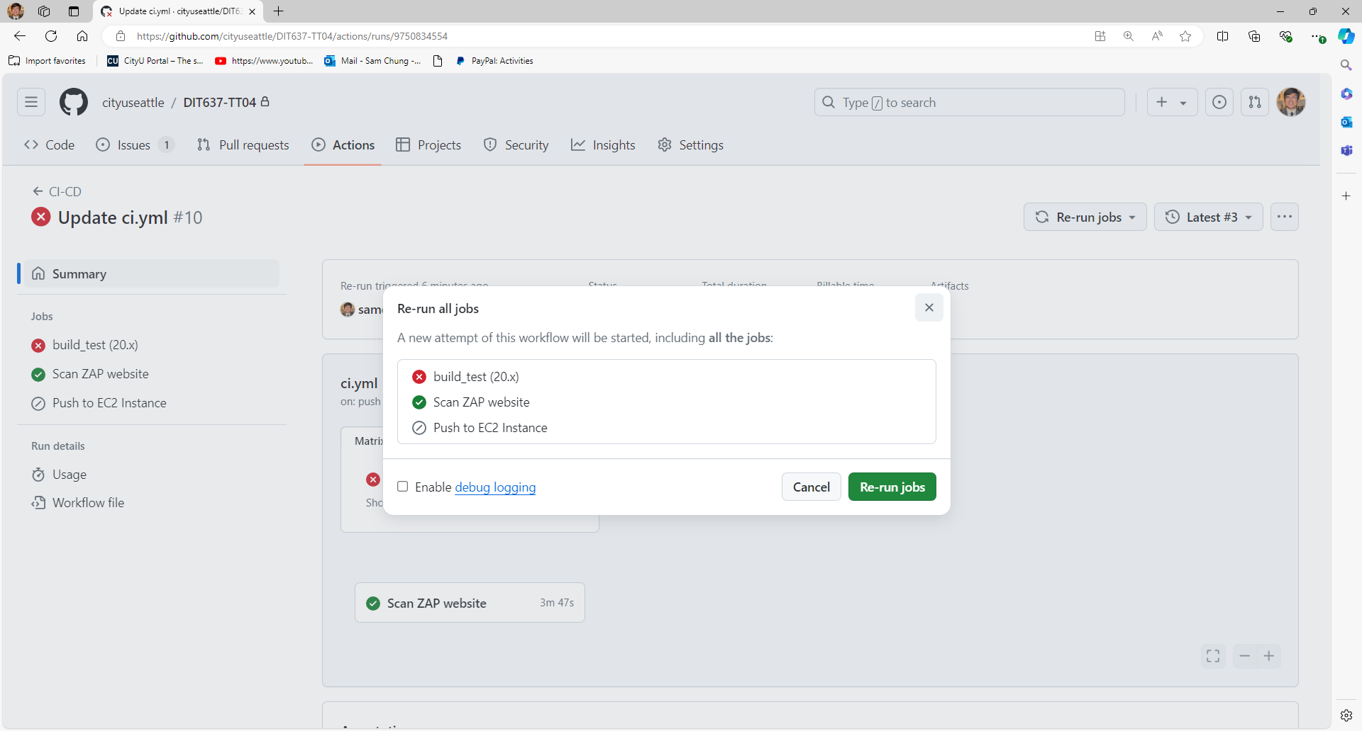

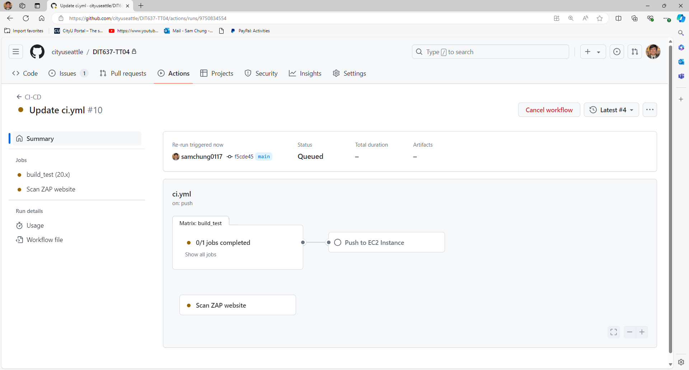

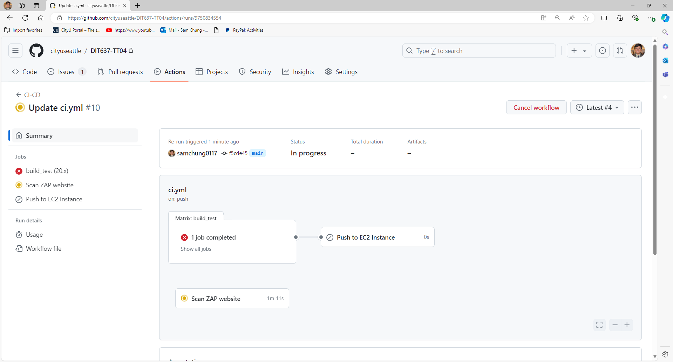

- Inspect the “Scan ZAP website” step. (Click on it)
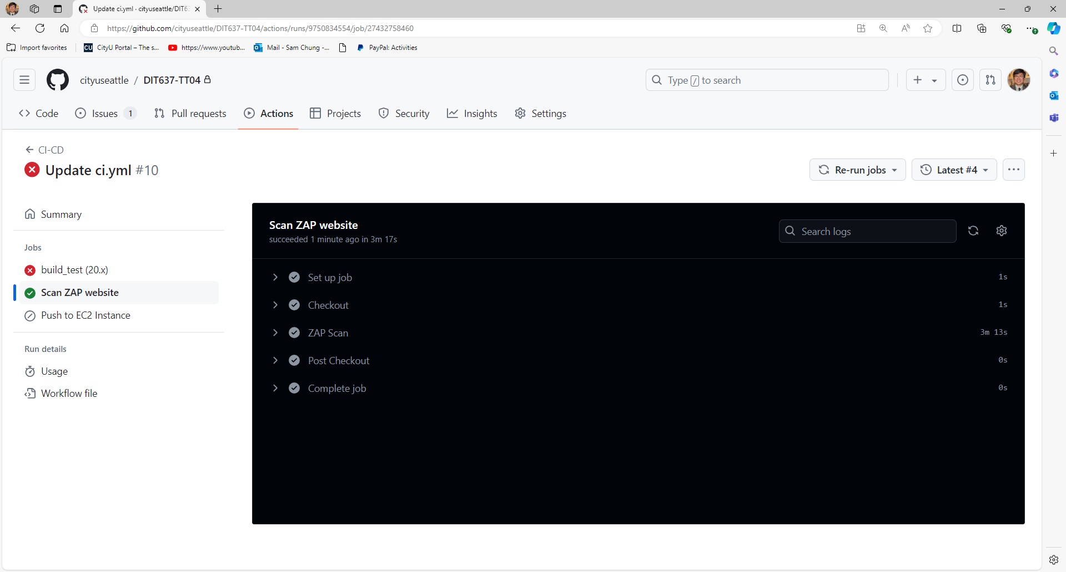
Note: ending up with an unsuccessful/partial scan is good enough. (Cross for ZAP Scan is OK)

- The screenshot of your ‘Scan ZAP Website – Zap Scan’ as ‘first_last_zap_scan.png’ by using your first and last name.
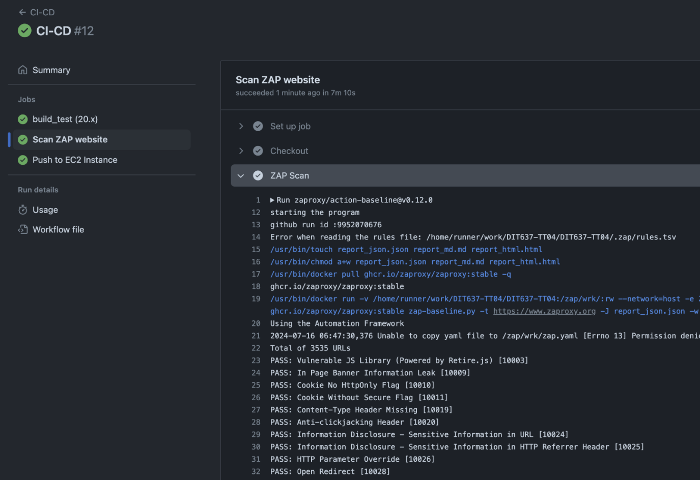

- Head back to the Issues tab and Click on ZAP Scan Baseline Report to see more information.
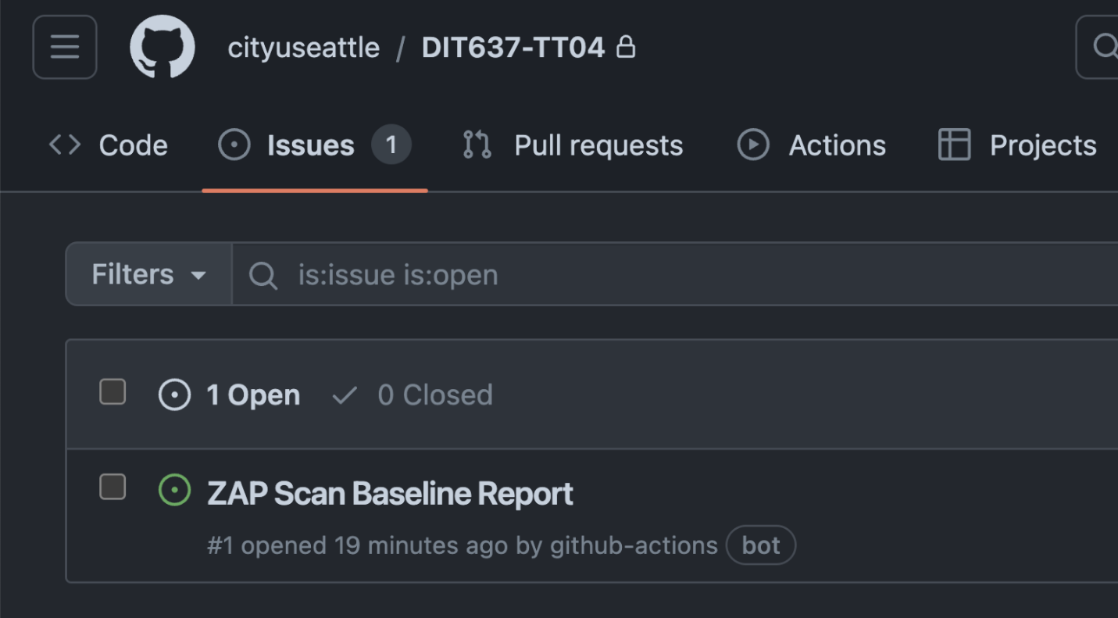

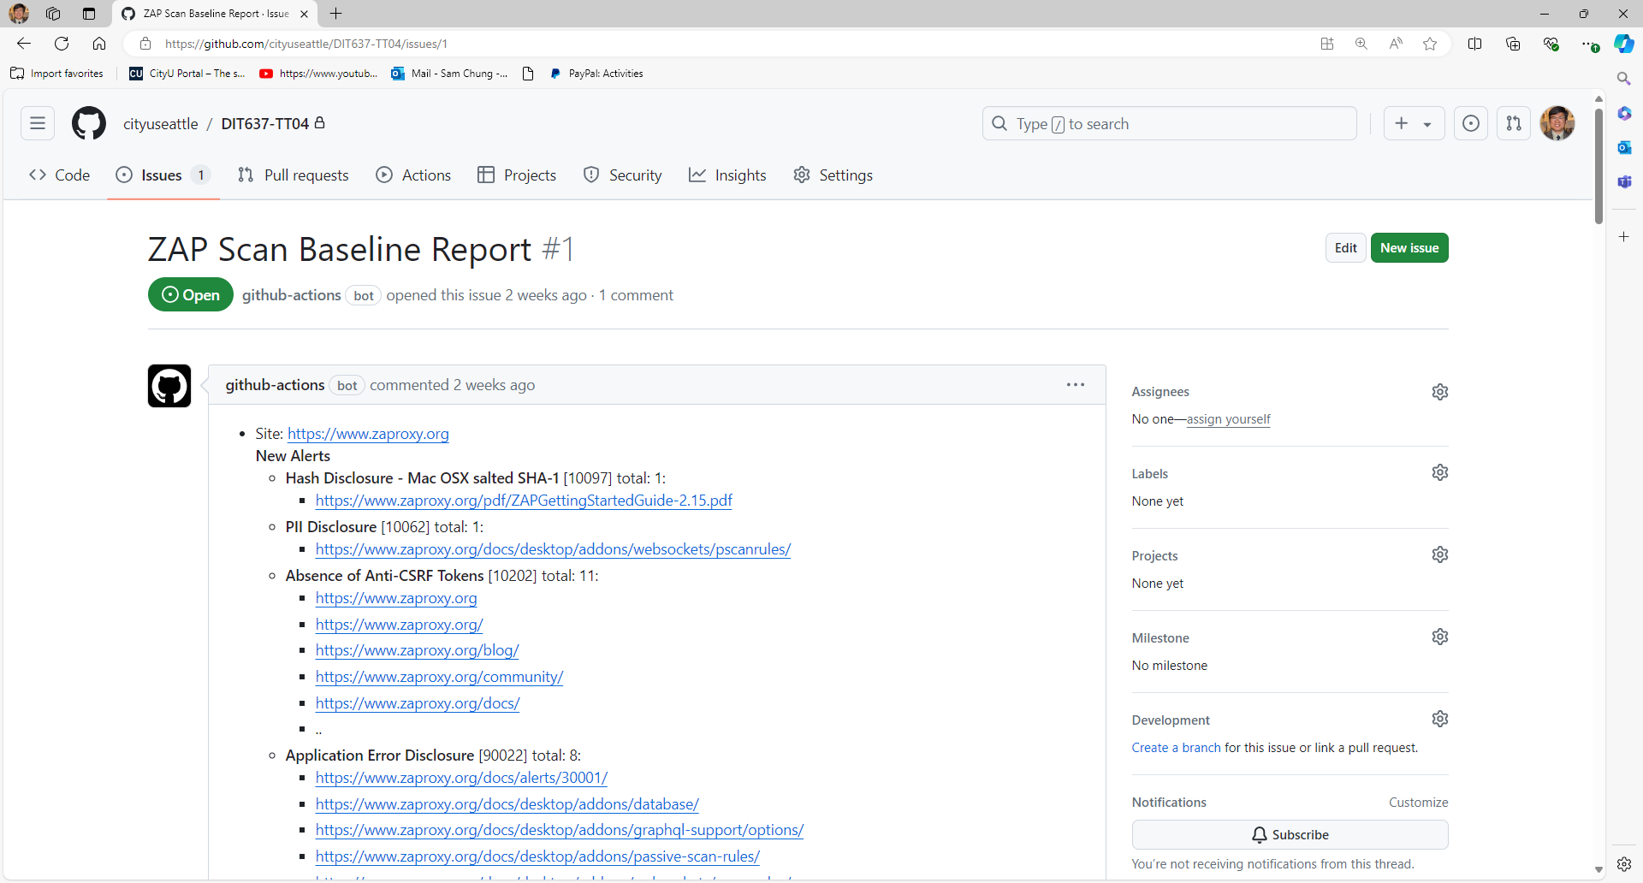

Breakdown of Workflow Trigger for GitHub Actions CI/CD

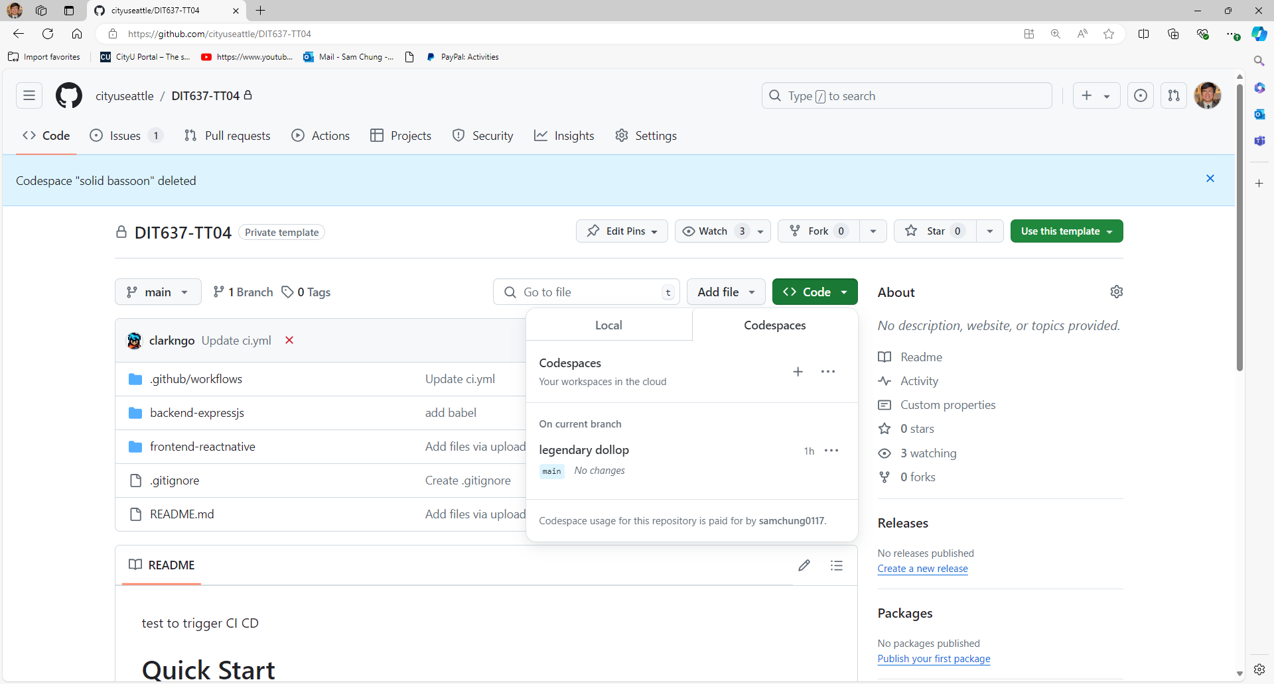

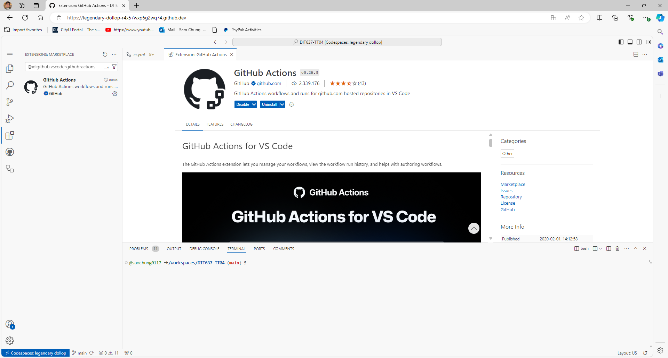

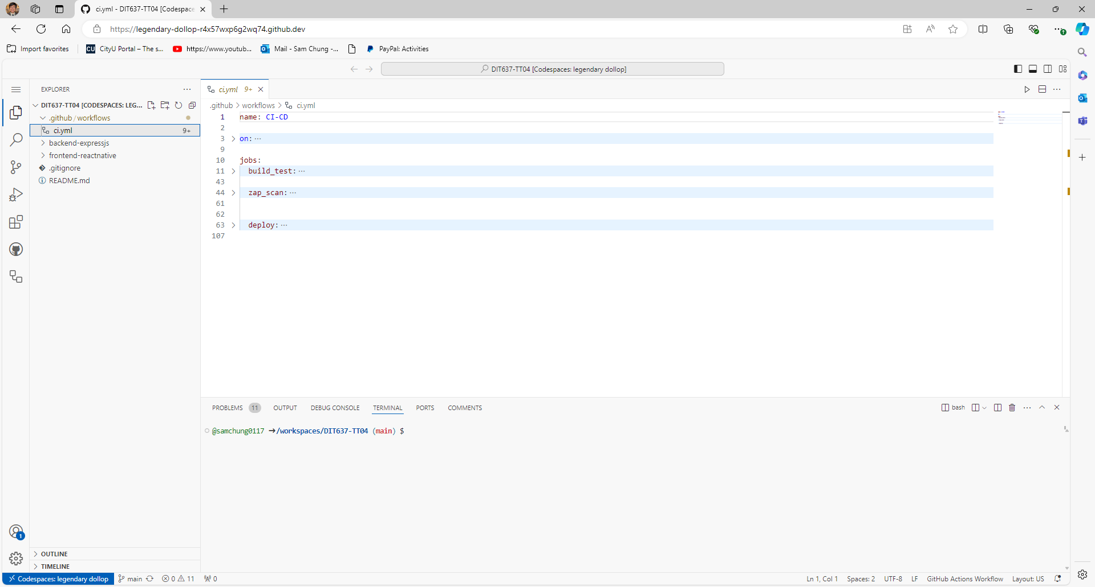
The GitHub Actions workflow defines a CI/CD pipeline for a Node.js (Express.js) application. It includes two jobs:
- build_test: Checks out the code, sets up Node.js, installs dependencies, prints environment variables, and runs tests.
- deploy: Checks out the code, creates a .env file, sets up SSH, deploys the code to an EC2 instance, installs dependencies, and starts the backend server on the EC2 instance.

The workflow is triggered on pushes and pull requests to the main branch, as well as manually.

Workflow Trigger
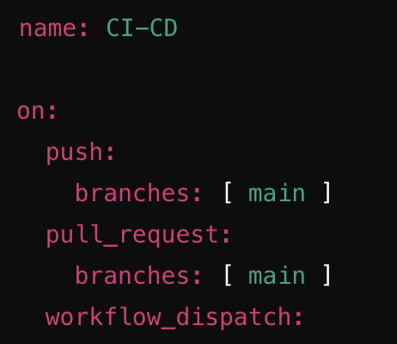
- name: The name of the workflow.
- on: Specifies the events that trigger the workflow.
  - push: Triggers the workflow on pushes to the main branch.
  - pull_request: Triggers the workflow on pull requests targeting the main branch.
  - workflow_dispatch: Allows manual triggering of the workflow.
permissions:
contents: read
actions: write
Grants the workflow read access to the repository contents and write access to GitHub Actions, which is required for uploading artifacts like the ZAP scan report.

Jobs Section

Build and Test Job
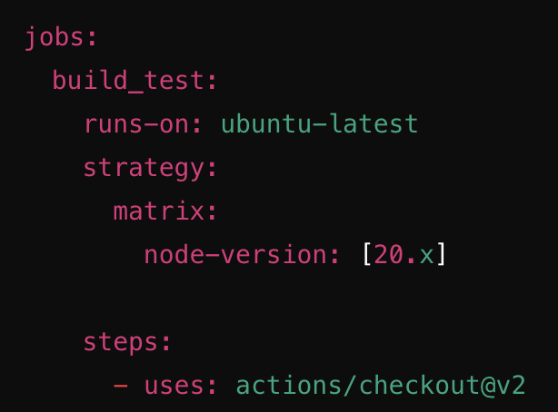
- jobs: Defines the jobs to be run in the workflow.
- build_test: The name of the job responsible for building and testing the application.
- runs-on: Specifies the type of runner to use, here it's ubuntu-latest.
- strategy.matrix: Allows running the job with different versions of Node.js (here it's version 20.x).
- steps: Defines the individual steps to be executed in the job.
  - actions/checkout@v2: Checks out the repository's code.

Setup Node.js
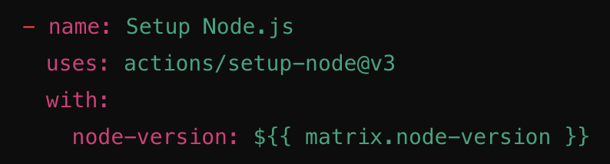
- actions/setup-node@v3: Sets up the specified version of Node.js.

Install Dependencies
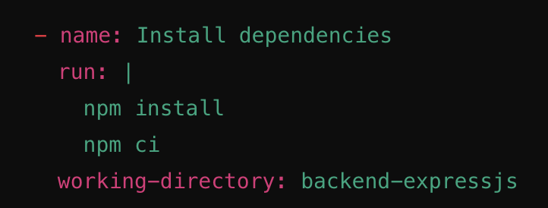
- run: Runs shell commands.
- working-directory: Specifies the directory where the commands should be executed.
  - npm install: Installs project dependencies.
  - npm ci: Cleans the node_modules folder and installs dependencies.

Test the Application
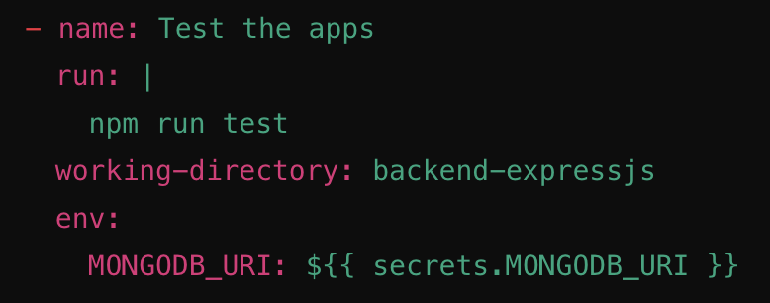
- npm run test: Runs the test script defined in package.json.
- env: uses the MongoDB connection string in GitHub Action secrets named MONGODB_URI

Web App Scanner
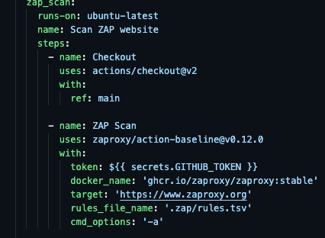
- zap_scan: This is the name of the job within the GitHub Actions workflow.
- runs-on: ubuntu-latest Specifies the environment in which the job will run. In this case, it uses the latest version of Ubuntu.

Steps
- Checkout Code
  - name: Checkout This step is named "Checkout".
  - uses: actions/checkout@v2 Uses the actions/checkout action version 2 to check out the code from the repository.
  - with: Specifies additional options for the checkout action.
    - ref: main Checks out the main branch of the repository.
- ZAP Scan
  - name: ZAP Scan This step is named "ZAP Scan".
  - uses: zaproxy/action-baseline@v0.12.0 Uses the zaproxy/action-baseline action version 0.12.0 to perform a baseline scan.
  - with: Specifies additional options for the ZAP baseline scan.
    - token: ${{ secrets.GITHUB_TOKEN }} Passes the GitHub token to the action, which is necessary for authentication and accessing repository resources.
    - docker_name: 'ghcr.io/zaproxy/zaproxy:stable' Specifies the Docker image to use for running ZAP. In this case, it uses the stable version of ZAP from GitHub Container Registry.
    - target: 'https://www.zaproxy.org' Sets the target URL for the scan. Here, it is the ZAP website.
    - rules_file_name: '.zap/rules.tsv' Specifies a rules file that contains customized rules for the scan. The file is located in the .zap directory and is named rules.tsv.
    - cmd_options: '-a' Passes additional command-line options to ZAP. The -a option tells ZAP to run the active scan after the passive scan.

AI-Assisted Documentation
Objective: Use Generative AI to help you articulate the architectural changes and key concepts you implemented in this lab.
Instructions:
- Select a Key Snippet: Identify the most important code you modified in this lab.
- Prompt an AI: Use a Large Language Model (e.g., Gemini or ChatGPT) with the following prompt:
"I am a student completing a technical lab on [Insert Lab Title]. I have implemented [Insert Feature] using [Insert Tool].
Based on this code snippet: [Paste your code here]
Please write a concise, professional 3-sentence summary for my GitHub README that explains the architectural role of this code and how it contributes to a 'Smart and Secure System'."
- Update your README: Review the AI-generated explanation, edit for accuracy, and paste it into your repository's README.md.
Document | [Insert Lab Title] | [Insert Feature] | [Insert Tool]
TT04 | DevSecOps | automated security scanning | GitHub Actions and OWASP ZAP

Pushing your work to GitHub
  - Go to Source Control on your GitHub codespaces and observe the pending changes.
  - Type the Message for your changes in the Message box on the top. For example,” Submission for TT04 – Your Name”
  - Click on the dropdown beside the commit button and select Commit & Push to update the changes to your repository main branch.
  - Select Yes when prompted.

